LAB 2 PASSIVE INFORMATION GATHERING

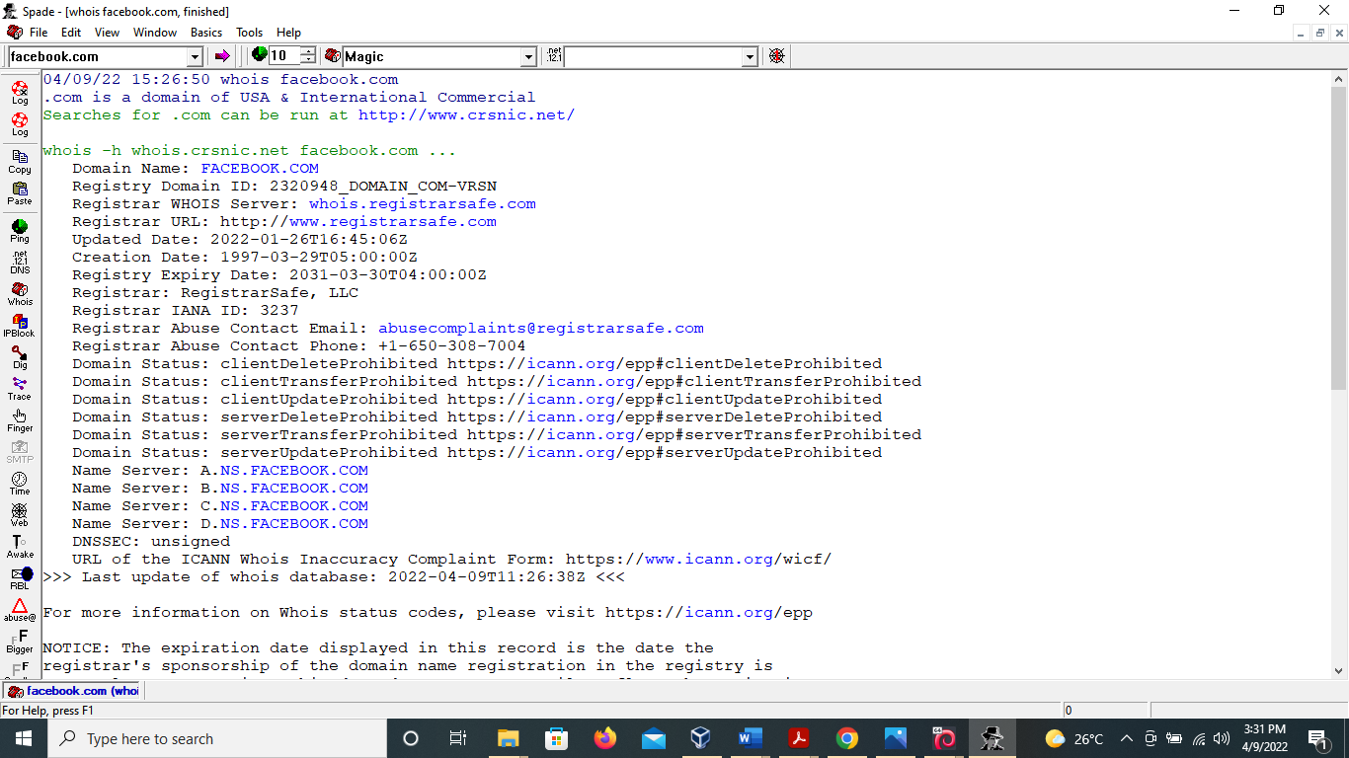

Whois lookup for [www.facebook.com](http://www.facebook.com) using Samspade.

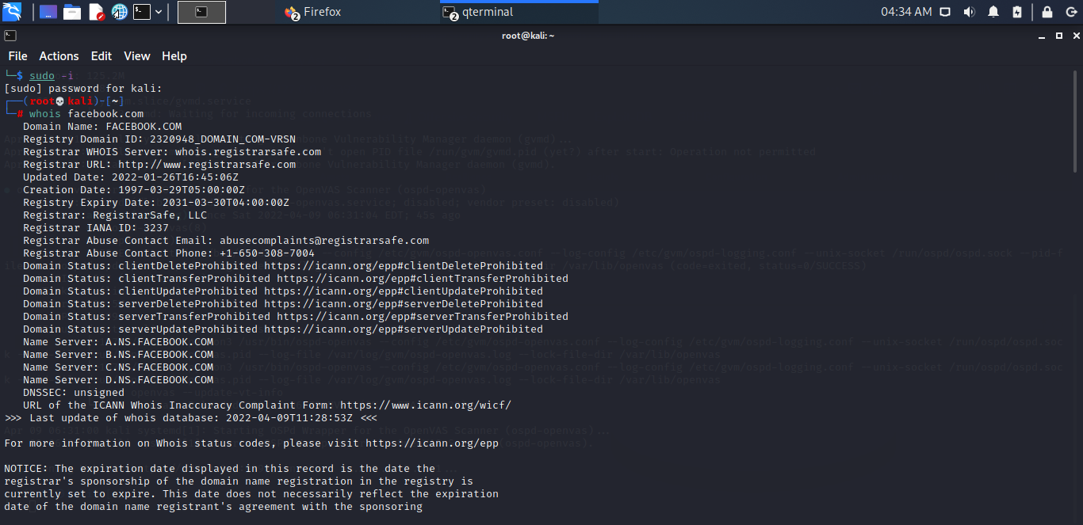

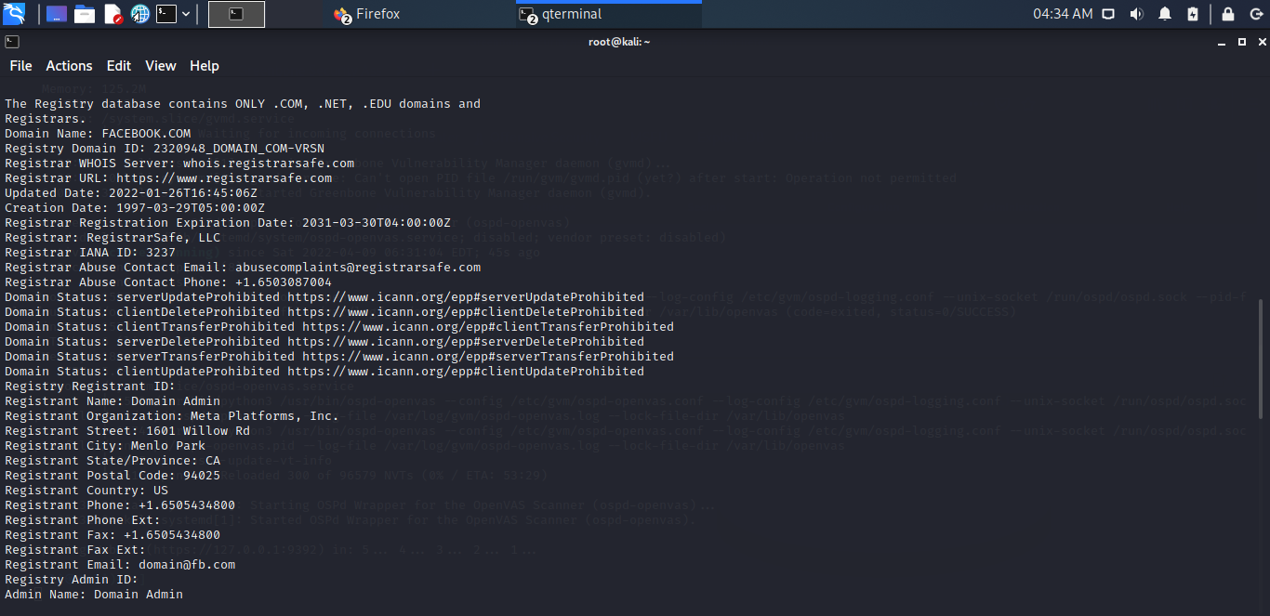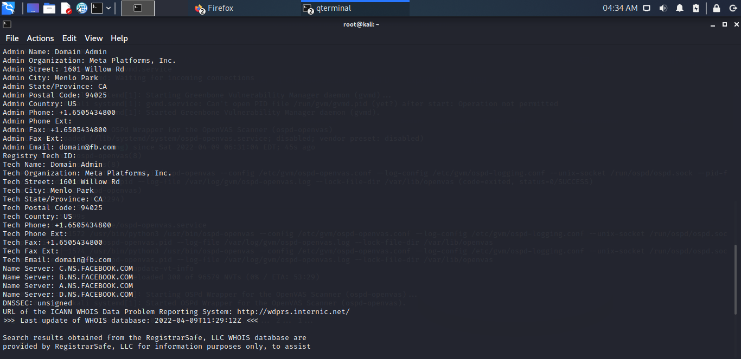

Whois lookup on linux.

There is more detailed information on the whois report generated by linux as compared to that of samspade.

Choose an organization and use Google to gather as much information as possible about it

Dangote group, [www.dangote.com](http://www.dangote.com).

* Company Address
* Phone numbers
* Email Address

Use the Google filetype search operator and look for interesting documents from the target organization

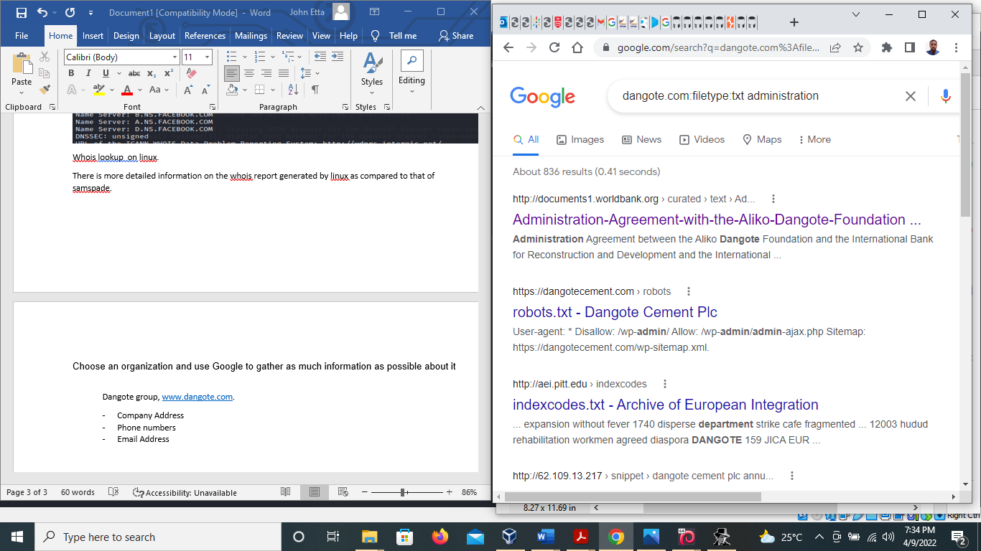

Re‑do the exercise on your company’s domain. Can you find any data leakage you were not aware of?

